From: http://www.zerohedge.com/news/2017-10-17/sprott-demand-marc-fabers-resignation-after-racist-diatribe
Update: as previewed earlier, Sprott announced that at the request of the Board of Directors and Sprott management, Marc Faber has resigned as a director of the Company effective immediately.
“The recent comments by Dr. Faber are deeply disappointing and are completely contradictory with the views of Sprott and its employees,” said Peter Grosskopf, CEO of Sprott. “We pride ourselves on being a diverse organization and comments and behavior of this sort will neither be condoned nor tolerated. We are committed to providing an inclusive workplace for all of our employees and we extend the same respect to our clients and investors.”
Separately, both CNBC and Fox Business Network, cable channels where he had appeared in the past, said they won't invite him on in the future.
* * *
Marc "Dr. Doom" Faber is in trouble, only this time it's not for yet another doomsday forecast which hasn't come true, but for launching into a racially charged diatribe telling subscribers to his newsletter that he was glad that “white people populated America, and not the blacks.”
The eccentric veteran investor and former Drexel director, who predicted the 1987 stock market crash and has been a fixture on financial television, claimed in his October 3 monthly newsletter that “the U.S. would look like Zimbabwe” if the country had been settled by black people instead of whites. In the latest edition of his 15-page investor letter, "The Gloom, Boom & Doom Report," Faber argued against the removal of confederate statues, saying the only crime of the men those monuments honored was to defend slavery and that the controversy distracts from more important debates, according to Bloomberg. There, inbetween quotes from George Orwell and historian Edward Gibbon and his opinions on universal basic income, Faber wrote the following:
"And thank God white people populated America, and not the blacks. Otherwise, the US would look like Zimbabwe, which it might look like one day anyway, but at least America enjoyed 200 years in the economic and political sun under a white majority."
He then added that "I am not a racist, but the reality — no matter how politically incorrect — needs to be spelled out."
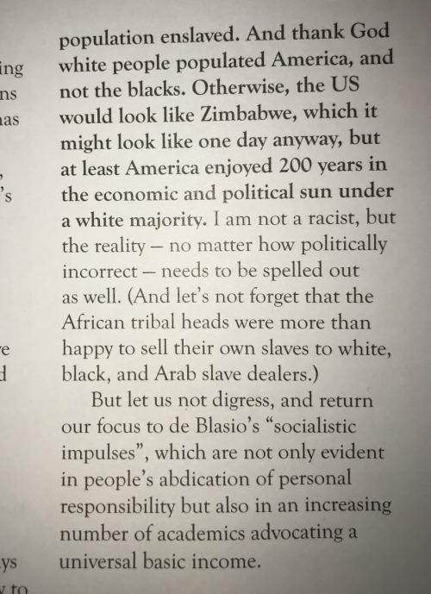
Source: @Beardedmiguel
In the newsletter, Faber's comments also address the confrontation in Charlottesville, Virginia, where violence sparked a national debate over race and monuments that honor prominent Confederate figures that Faber decided to weigh in on. Faber called the monuments "statues of honourable people whose only crime was to defend what all societies had done for more than 5,000 years: keep a part of the population enslaved."
Asked for a comment by the WSJ Faber responded in an e-mail: “I am naturally standing by this comment since this is an undisbutable (SIC) fact.”
Reached for comment by CNBC, Faber similarly did not back away from his statements: "If stating some historical facts makes me a racist, then I suppose that I am a racist. For years, Japanese were condemned because they denied the Nanking massacre." In addition to the brief statement, he sent a link to a USA Today story titled, "Banned in Biloxi, 'To Kill a Mockingbird' raises old censorship debate," focusing on the Harper Lee classic.
His comments drew an immediate reaction, and as Bloomberg reports, Sprott CEO Peter Grosskopf said will ask the board to demand the immediate resignation of Marc Faber, who is a director on Sprott's board. Grosskopf added that he had already spoken to the company chairman about Marc Faber.
Grosskopf also said that the company is “deeply disappointed” and shocked by Faber’s comments.
“We take pride in the fact that we are a global organization with a racially inclusive employee, client and investment base. Our policies in that regard are crystal clear and well known. As such these comments and thinking are completely unacceptable and we will be taking immediate steps to distance ourselves from Mr. Faber and request his resignation from our board."
According to the WSJ, the comments sparked a broad backlash from investors and market commentators Tuesday. CNBC and Fox Business Network, cable channels where he had appeared in the past, said Tuesday they don’t intend to book him in the future.

